

**ANALYSIS THE CUSTOMER SATISFACTION LEVEL REGARDING THE WORKABILITY OF LEASED LINE AND LANDLINE CONNECTION**

**NAME: ABHISHEK BHOWMICK**

**ROLL: 107/MBA/192002**

**REGISTRATION NUMBER -107-1111-0203-19**

**SPECIALIZATION: BASM**

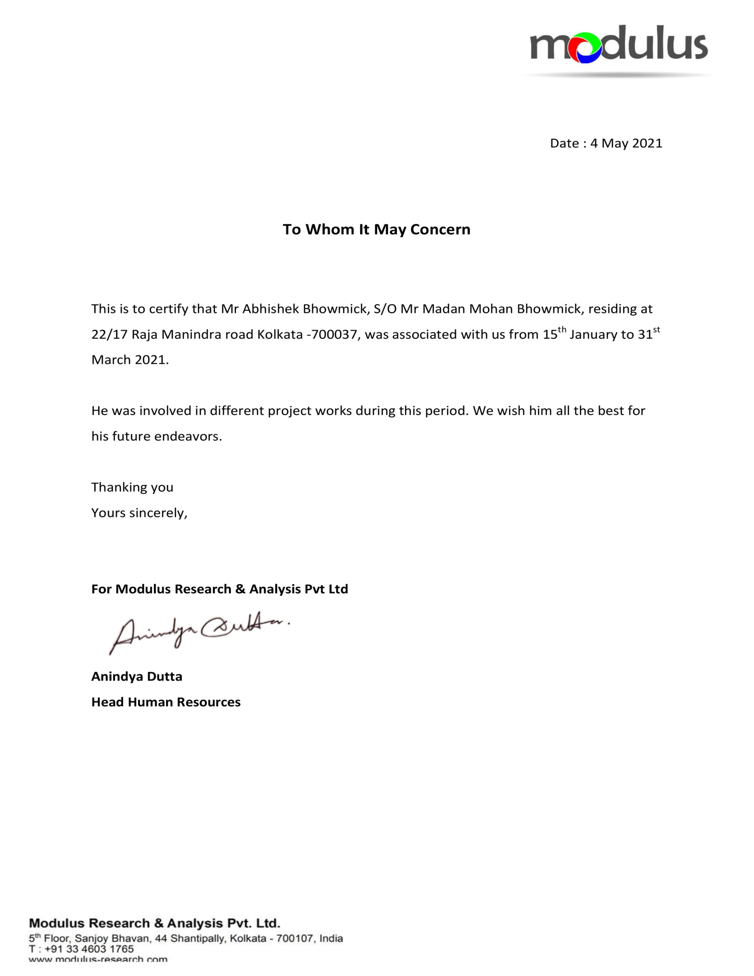

**ACKNOWLEDGEMENT**

I want to give my gratitude to my mentor Mr Nirmal Ray and Mr Krishnendu Sengupta who have helped a lot to complete my internship project successfully. I have gathered huge ideas and motivations from my other team members and tutors for finishing the project efficiently. I also show my love and respect to my parents and other respective teachers for encouraging me throughout the project and make it successful.

Thanks and Regards,

Abhishek Bhowmick

IISWBM

**Abstract**

The main purpose of the study is to analyse the customer satisfaction level on a different brand of leased line and Landline connection from all aspects. To find this, the researcher has prepared three research objectives and utilised primary quantitative research methods to collect, analyse and interpret the results. It is found that that sector that are using wireline service they are very much satisfied on that it was varied on the different brand based on their customer service, Internet speed, and landline service. Customers are still believed on leased line and landline. They have changed their service providers but still, they are satisfied with the leased line. It means that no doubt that Reliance Jio is the most satisfactory brand for the customer but when we are seeing the fair charges then Airtel also here in competition. It is recommended that the study could have been better if the researcher has utilised mixed research method for analysing the respective study.

Table of Content

Introduction 5

Background 5

Aim 5

Objective 5

Research Question 6

Importance of the Study 6

Literature Review 6

Overview of leased line and landline connection 6

Importance of leased line and landline connection 7

Impact of COVID-19 pandemic on leased line connection 7

Strategy to implement leased line and landline 8

Methodology 9

Philosophy 9

Methodological approach 9

Research Design 10

Sampling and Data Analysis Technique 10

Data Analysis & Findings (Refers to Appendix) 11

Conclusion and Recommendation 23

Conclusion 23

Recommendation 24

References 25

Appendix 28

# Introduction

## Background

Leased line internet access service is nothing but an end-to-end broadband wireline connection that means a dedicated direct line from the service provider's server to the customers' server to access the internet. Leased line internet access service enables an [end-user](https://itlaw.wikia.org/wiki/End_user) to retrieve [files](https://itlaw.wikia.org/wiki/File) from the [World Wide Web](https://itlaw.wikia.org/wiki/World_Wide_Web), the [end](https://itlaw.wikia.org/wiki/End_user)-user can interact with [information](https://itlaw.wikia.org/wiki/Information) [stored](https://itlaw.wikia.org/wiki/Store) on the [service provider](https://itlaw.wikia.org/wiki/Service_provider)'s facilities (Kamoun and Outay, 2019). To the extent a provider offers end users a capability to [store](https://itlaw.wikia.org/wiki/Store) [files](https://itlaw.wikia.org/wiki/File) on the [service provider](https://itlaw.wikia.org/wiki/Service_provider)'s [computers](https://itlaw.wikia.org/wiki/Computer) to establish “[home pages](https://itlaw.wikia.org/wiki/Home_page),” the consumer is utilizing the “capability for [storing](https://itlaw.wikia.org/wiki/Storing)  or making available [information](https://itlaw.wikia.org/wiki/Information).”

A landline is a telephone that transmits signals converted from audio data through physical media, such as wire or fibre optic cable, rather than through wireless transmission as is the case with mobile phones. The phone base and the receiver (or handsets) are connected by a cord. The company provided landline or fixed-line services or desk phones only for calling purposes. There are three types of connection.

**PRI:** Primary Rate Interface (PRI) service provides 30 simultaneous calls/voice channels on a single link with the capability of up scaling several channels as per future requirements.

**SIP Trunk:** Session Initiation Protocol (SIP) Trunk is an advanced IP Voice Connectivity product. In a single physical link, it can support up to 1500 simultaneous calls.

**Centrex:** Private branch exchange like the extension lines for each employee.

## Aim

The research aims to analyse the customer satisfaction level on a different brand of leased line and Landline connection from all aspects.

## Objective

* To discuss the importance of leased line and landline connection on customer satisfaction.
* To analysis the customer satisfaction level in terms of various brands.
* To recommend strategies for implementing wireline and landline connection to enhance customer satisfaction.

## Research Question

* What is the importance of leased line and landline connection?
* What is the satisfaction level of the customer on the leased line and landline connection?
* How to implement the strategy of leased line connection to enhance customer satisfaction?

## Importance of the Study

Nowadays, leased line connection is extinct. But till now more companies are using Wi-Fi connection so the researcher wants to know the overall satisfaction level concerning brands of the service provider.

# Literature Review

## Overview of leased line and landline connection

According to Guterbock *et al.* (2018), a leased line network includes interlinked connection and redistribution systems. The network allows information like voice and data to travel electronically. Traditionally, local and long-distance telephony including voice calls, messaging, and fax were the primary leased line services. They travelled or were transmitted, over a network of copper wires and switches. The wires and switches connected calls between users. Now, the network includes the copper infrastructure connecting traditional landlines and payphones. It mainly includes the broadband network delivering VoIP (Voice over Internet Protocol), Internet, TV services, and managed private communications. Broadband infrastructure is a critical resource for economic development. Most countries across the globe have strategic plans in place like the National Broadband Plan to expand and develop their network.

A landline telephone (also known as landline, land-line, mainline, home phone, landline, fixed-line, and wireline) is a [phone](https://en.wikipedia.org/wiki/Telephone) that uses a [metal wire](https://en.wikipedia.org/wiki/Wire) or [optical fibre](https://en.wikipedia.org/wiki/Optical_fiber) [telephone line](https://en.wikipedia.org/wiki/Telephone_line) for transmission as distinguished from a [mobile cellular line](https://en.wikipedia.org/wiki/Cellular_network), which uses [radio waves](https://en.wikipedia.org/wiki/Radio_waves) for transmission. In 2003, the [CIA World Fact book](https://en.wikipedia.org/wiki/CIA_World_Factbook) reported approximately 1.263 billion main [telephone](https://en.wikipedia.org/wiki/Telephone) lines worldwide (Cambiagno *et al.,* 2021). [China](https://en.wikipedia.org/wiki/China) had more than any other country, at 350 million, and the [United States](https://en.wikipedia.org/wiki/United_States) was second with 268 million. The [United Kingdom](https://en.wikipedia.org/wiki/United_Kingdom) had 23.7 million residential fixed home phones.

## Importance of leased line and landline connection

According to Pantunn and Pattaramalai (2017), Technology is impacting every part and parcel of our lives in our rapidly changing world – from where and how we conduct work, to whether or not we thrive economically and socially. Technology and broadband can when available improve and enhance the way we work and live. With the introduction and accelerated advancement of technologies, having access to affordable, redundant, and abundant broadband is quickly becoming the most critical infrastructure of our time, just like electricity, transportation, and roadways were early last century (Kathuria *et al.,* 2018). To address the possibilities and potential of broadband, both the private and public entities are building networks all over the globe to support the Internet needs of both today and the foreseeable future. We do not yet know the far-reaching impacts that the Internet will have on our lives and on generations to come.

With the prevalence of mobile phone use around the globe, we tend to forget the importance of our reliable landline phone service. While mobile phones are at the forefront of phone communication these days, landlines still play a very important role in telecommunications. Overall, local and long-distance calls are cheaper. Security systems require landlines and they are more difficult to hack than mobile phones as stated by Zelevinsky (2021). Not to mention that if you dial 9-1-1 from a landline phone, the emergency responders can pinpoint your exact location, unlike a mobile phone. Loss of signal while using mobile phones is another reason to also have a home or office phone as well especially in rural areas. With a landline phone, you can hold a crystal clear conversation with a loved one or business client without losing quality or reception. Although mobile phones may be used more in today’s society, there will always be a need for landlines. Nowadays, some of the industry is still using Leased line and landline for their business purpose as they know that these will help their business very much and cost also less (Sumter *et al.,* 2018). For example, Bank and Finance sector, Healthcare sector, some IT sector, Education sector, etc.

## Impact of COVID-19 pandemic on leased line connection

When the lockdown started, it took the initial week or 10 days just to figure out how we go about with our work. We believe the second phase should not be as difficult as the first phase as we are more prepared for it. According to Grasdijk *et al.* (2021), the only challenge we foresee now is the supply of raw materials required during the maintenance or installation of broadband connections. Even though internet-providing companies are considered essential services, the manufacturing companies for switches, cables, etc. are not. This poses a problem in supply, while the demand continues to rise.

The broadband industry is expecting to grow as customers require stability and speed to increase productivity from home. This switch is also expected to continue post-Covid-19 lockdown as customers would not immediately want to rely on mobile internet speed and also continue maintaining distance to avoid contracting the virus (Kunal *et al.,* 2019).

## Strategy to implement leased line and landline

Web Services Provider markets its products as solutions to high traffic and bandwidth-intensive Web companies whose online reliability and speed are critical to daily business. Target companies include online stock trading companies, e-tail, and corporations with graphics and/or streaming video. Sales are made through Web Services Providers’ national advertising campaign. The sales process involves several steps which include (Sumter *et al.,* 2018): The first contact when the perspective customer’s first impression is made while viewing one of the magazines in which we advertise. At this point, the customer will call our sales line or go to our website.

The customer can then call the sales line where a trained representative will answer questions and proceed with initiating service and billing. This approach will be used because each customer’s concerns and needs will be met immediately to capture the customer at this point of contact (Wang *et al.,* 2019). The average sales cycle from the first contact to closing the sale is between one and seven days. For a landline call to work, the telephone must be connected to wires which then link to the rest of the phone network. The network itself begins in your own home, where a pair of copper wires for every phone line that you have runs in from a box somewhere at the roadside (frequently referred to as the entrance bridge) into your house (Kobaiz and Ghrare, 2019). Those wires go to your phone jacks, to which your telephones are connected. The entrance bridge is connected to a thick cable that runs along your road, and either goes directly to the phone company's switch, or to another, larger box which acts as a digital concentrator.

# Methodology

## Philosophy

It has to be acknowledged that the positivism research philosophy is difficult to be explained in a precise and succinct manner. This is because there are vast differences between settings in which positivism is used by researchers. The number variations in explaining positivism may be equal to the number of authors who addressed the area of [research philosophy](https://research-methodology.net/research-philosophy/) (Haunschild *et al.,* 2020). Nevertheless, in its essence, positivism is based on the idea that science is the only way to learn about the truth. The text below explains positivism with a focus on business studies in particular.

Positivism depends on quantifiable observations that lead to statistical analyses. It has been noted that "as a philosophy, positivism is following the empiricist view that knowledge stems from human experience. It has an atomistic, ontological view of the world as comprising discrete, observable elements and events that interact in an observable, determined and regular manner". Moreover, in positivism studies, the researcher is independent of the study and there are no provisions for human interests within the study (Haunschild *et al.,* 2020). Argue that as a general rule, positivist studies usually adopt [the deductive approach](https://research-methodology.net/research-methodology/research-approach/deductive-approach-2/), whereas [the inductive research approach](https://research-methodology.net/research-methodology/research-approach/inductive-approach-2/) is usually associated with a [phenomenology philosophy](https://research-methodology.net/research-philosophy/phenomenology/). Moreover, positivism relates to the viewpoint that the researcher needs to concentrate on facts, whereas phenomenology concentrates on the meaning and has provision for human interest (Alharahsheh and Pius, 2020).

## Methodological approach

The deductive approach has been followed in this research project for the development of the hypothesis of the topic, and this has been developed based on the existing theories of research methodology (Hong *et al.,* 2021). The hypothesis of this research project will be tested as per the design of the research strategy. The particular aim of this research project has been reasoned to throw this deductive methodological approach generally (Pandey, 2019). The deductive approach has been helpful to develop the hypothesis based on the existing theory and design a research strategy for the testing of the hypothesis of the research project. Therefore, the researcher will use the deductive approach for the completion of this research project.

## Research Design

As the researcher is using the primary data collection method so the research design is the descriptive research design. Descriptive research is defined as a research method that describes the characteristics of the population or phenomenon studied. This methodology focuses more on the "what" of the research subject than the "why" of the research subject (Bloomfield and Fisher, 2019). The descriptive research method primarily focuses on describing the nature of a demographic segment, without focusing on "why" a particular phenomenon occurs. In other words, it "describes" the subject of the research, without covering "why" it happens (Tongkaw and Tongkaw, 2018).

For example, an apparel brand that wants to understand the fashion purchasing trends among New York buyers will conduct a demographic survey of this region, gather population data and then conduct descriptive research on this demographic segment. The study will then uncover details on "what is the purchasing pattern of New York buyers," but not cover any investigative information about "why" the pattern exists. Because of the apparel brand trying to break into this market, understanding the nature of their market is the study's objective.

## Sampling and Data Analysis Technique

The researcher is using the random sampling method and python is using it for the statistical calculation. Random sampling is a part of the sampling technique in which each sample has an equal probability of being chosen (Geller, 2020). A sample chosen randomly is meant to be an unbiased representation of the total population. If for some reason, the sample does not represent the population, the variation is called a sampling error.

Random sampling is one of the simplest forms of collecting data from the total population. Under random sampling, each member of the subset carries an equal opportunity of being chosen as a part of the sampling process (Etikan and Bala, 2017). For example, the total workforce in organizations is 300, and to conduct a survey, a sample group of 30 employees is selected to do the survey. In this case, the population is the total number of employees in the company and the sample group of 30 employees is the sample. Each member of the workforce has an equal opportunity of being chosen because all the employees who were chosen to be part of the survey were selected randomly (Griebeler *et al.,* 2021). But, there is always a possibility that the group or the sample does not represent the population as a whole, in that case, any random variation is termed as a sampling error.

# Data Analysis & Findings (Refers to Appendix)

The research is going to analyses customer satisfaction with broadband leased line connection.

**Sample Size: 41**

|  |  |
| --- | --- |
| Current Service Provider | Number of Samples |
| Airtel | 19 |
| BSNL | 12 |
| Reliance Jio | 5 |
| Tata Tele Services | 3 |
| Vodafone | 2 |

Table 1: Sample Size for the different service provider

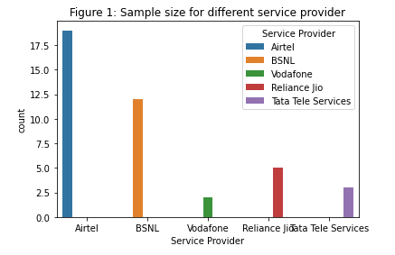

**Q1. How likely are you to recommend a selected brand for your business? Please answer on a scale from 0 to 10, where 0 means you definitely would not recommend and 10 means you definitely would recommend.**

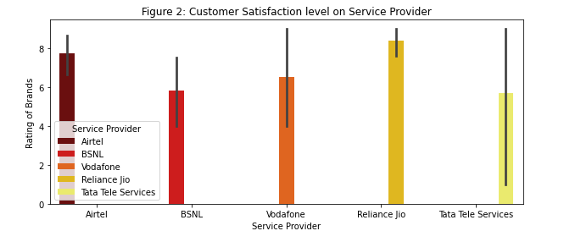

The above graph is showing that the customer satisfaction level of Reliance Jio is higher than any other brand. Customer is very much satisfied to use the Reliance Jio that’s why they are recommending to anyone as their internet speed is good and customer service also better than any other bands.

**Q2. Ease of getting touch with Sales Account Manager. Please answer on a scale from 0 to 10, where 0 means Extremely Dissatisfied and 10 means Extremely Satisfied.**

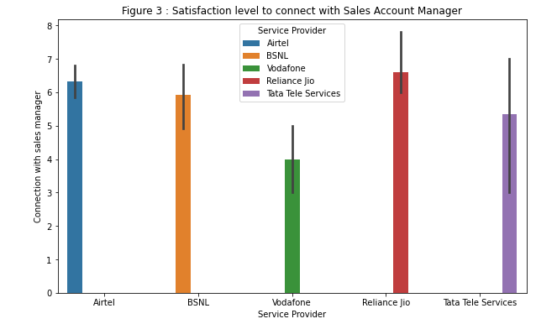

The above graph is showing that the customer satisfaction level to connected with the sales account manager. Customers are very much satisfied to contact the sales account manager of Reliance Jio as their satisfaction level is higher than other service providers.

**Q3. Time is taken to complete the negotiation process with the Sales Account Manager. Please answer on a scale from 0 to 10, where 0 means Extremely Dissatisfied and 10 means Extremely Satisfied.**

The graph is showing the satisfaction level of the customer on the time taken to complete the negotiation process. Here also the customer satisfaction level is high in Reliance Jio. Reliance Jio’s customers are satisfied to speak with the sales account manager about the plan which they will take for their use.

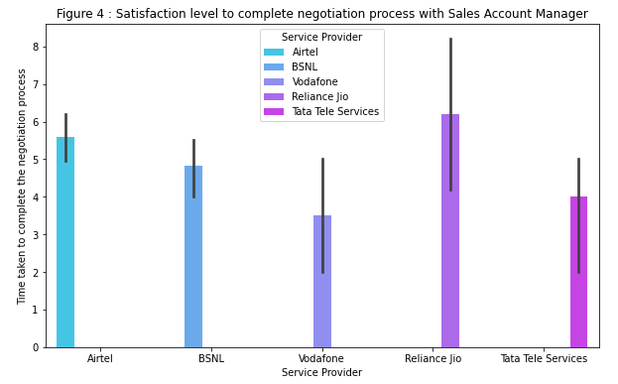

**Q4. The clarity in communication during the installation phase.Please answer on a scale from 0 to 10, where 0 means Extremely Dissatisfied and 10 means Extremely Satisfied.**

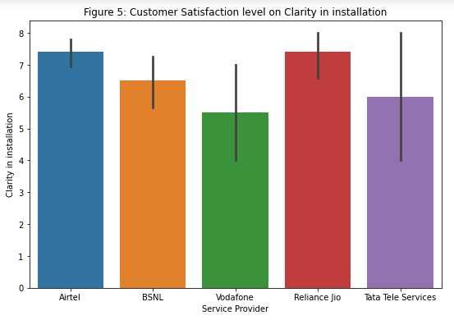

The above graph is showing the customer satisfaction level on Clarity at the time of installation. Here the satisfaction level of Airtel and Reliance Jio are almost the same. But the other brands are less than Airtel and Reliance Jio. When the clarity is good on any product the sell must be higher.

**Q5. Pro-activeness in sharing installation plan and status update. Please answer on a scale from 0 to 10, where 0 means Extremely Dissatisfied and 10 means Extremely Satisfied.**

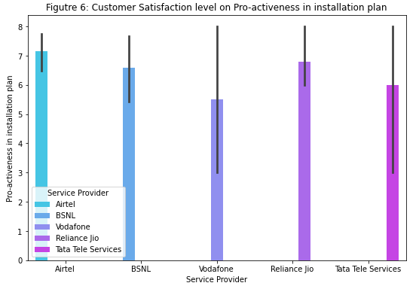

The above graph is showing the pro-activeness of the installation plan and status update. Here the customer satisfaction level on pro-activeness is high in brand Airtel. If the pro-activeness of installation satisfies the customer then they can change their existing plan and go for a higher plan.

**Q6. Voice quality of Landline/Wireline. Please answer on a scale from 0 to 10, where 0 means Extremely Dissatisfied and 10 means Extremely Satisfied.**

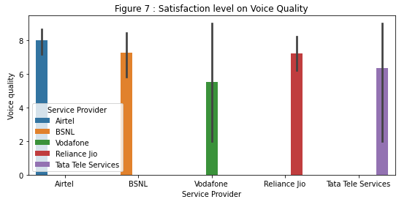

The above graph is showing the voice quality of the landline connection. Voice quality is the main part of landline connection. While landline services occasionally have downtime, they are most reliable for day-to-day use and in the case of power outages or emergencies. The voice quality is clear and feels immediate. The graph shows that the voice quality of Airtel satisfied the customer very much than another brand.

**Q7. Continuous connection without call drops. Please answer on a scale from 0 to 10, where 0 means Extremely Dissatisfied and 10 means Extremely Satisfied.**

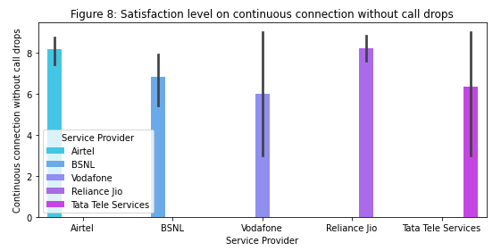

The above graph is showing the voice connectivity without call drops. Voice connectivity without call drop will satisfy the customer at the higher point. If the call disconnects several times during important talk among two people it will be very dissatisfied the customer. Here the graph shows that the customer satisfaction level on voice connectivity without call drops for Airtel and Reliance Jio’s are nearly and higher than other service providers.

**Q8. Speed of Internet connection for Wireline data services. Please answer on a scale from 0 to 10, where 0 means Extremely Dissatisfied and 10 means Extremely Satisfied.**

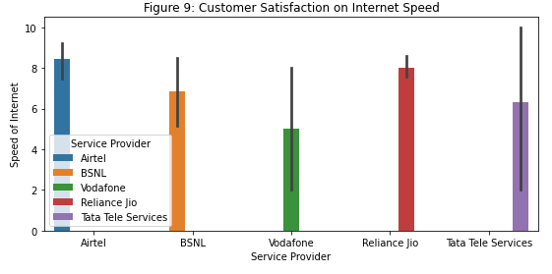

The above graph is showing customer satisfaction with internet speed. Internet speed is the main part of any internet service provider. If the internet speed is high then customer satisfaction is high. Now day without the internet anybody can't work anything so good speed of the internet can do the work faster. From the above graph as per customer satisfaction, the internet speed of Airtel is greater than any other brand and also more preferable for the customer.

**Q9. Dispute resolution related to Billing. Please answer on a scale from 0 to 10, where 0 means Extremely Dissatisfied and 10 means Extremely Satisfied.**

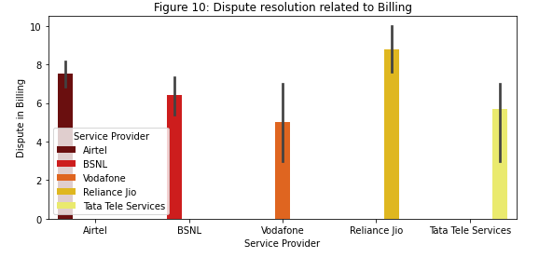

Billing is the main part for any customer who is the end-user of any service provider. The dispute in billing is dissatisfied with the customer very much. The above graph is showing that the customers of Reliance Jio are more satisfied than any other brand as dispute-related billing is very less for this brand only.

**Q10. Resolution/Update provides by customer care. Please answer on a scale from 0 to 10, where 0 means Extremely Dissatisfied and 10 means Extremely Satisfied.**

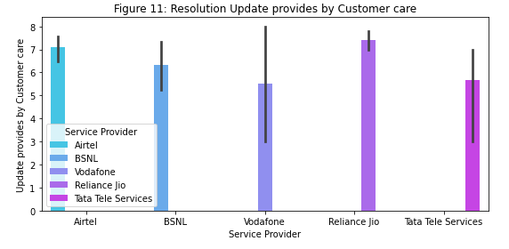

**Q11. Timely and Quality updates on your Complaint, Request, Query. Please answer on a scale from 0 to 10, where 0 means Extremely Dissatisfied and 10 means Extremely Satisfied.**

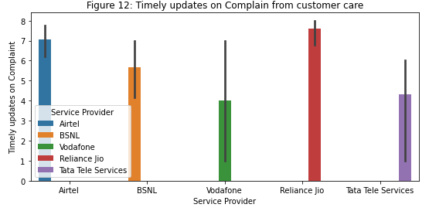

The main characteristic of good customer service is taken from the resolution update within the time. If the customer care gives updates on complaints that are raised by the end-user then the satisfaction level goes up for that particular service provider. Customer care must be very polite and has to be updated on complaints so that customer can complete their work as soon as possible. If customer care is delaying their process it is very difficult for end-user to handle the total circumstances of the organization. There must be a different kind of problem raised by the customer. E.g. Server down, Landline not connected, Network speed is slow, Bill not received, etc. Server down of any office may lose huge amount of money for a company like finance, bank, etc. if the customer will not give the updates on time. Here showing that End-users are very much satisfied with Reliance Jio’s customer care as they are giving quality updates soon via phone, mail, or massage.

**Q12. Responsiveness of field engineer. Please answer on a scale from 0 to 10, where 0 means Extremely Dissatisfied and 10 means Extremely Satisfied.**

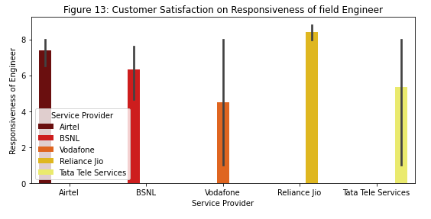

**Q13. The ability of the field engineer to resolve the technical issue. Please answer on a scale from 0 to 10, where 0 means Extremely Dissatisfied and 10 means Extremely Satisfied.**

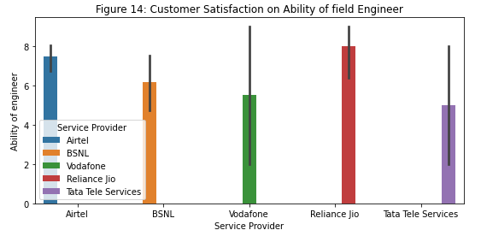

**Q14. Qualify the time taken for resolution by the field engineer. Please answer on a scale from 0 to 10, where 0 means Extremely Dissatisfied and 10 means Extremely Satisfied.**

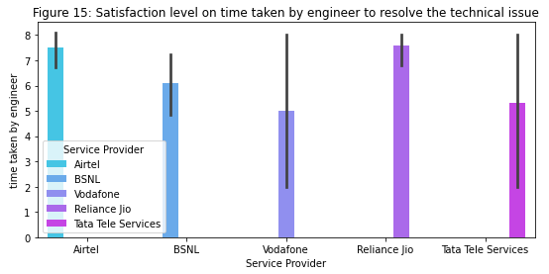

The field engineer is very much important from the time of installation. Most of the time for server issues field engineer will come and solve the problem soon. So responsiveness is very important for any field engineer. If any organization wants to reinstall the hard disk in the server then they must inform the customer care and after that from the service provider's office, they sent one engineer to resolve this problem. At the time of re-installation engineer must be down a server to the whole office if the engineer will take a huge time to resolve the issue then it will be a big problem. The engineer must technically very good and they should take minimum time only to resolve the problem. That's why a field engineer can satisfy the customer. Researchers from the above three graphs have shown that the field engineer Reliance Jio's approach to responsiveness is the best in terms of customer satisfaction. However, Airtel and Reliance Jio are the best in terms of customer satisfaction in terms of both technical problem-solving ability and time.

**Q15. Is a brand I trust on a selected service provider? Please answer on a scale from 0 to 10, where 0 means Extremely Dissatisfied and 10 means Extremely Satisfied.**

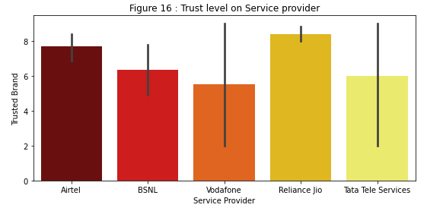

**Q16. Our experts in the field?Please answer on a scale from 0 to 10, where 0 means Extremely Dissatisfied and 10 means Extremely Satisfied.**

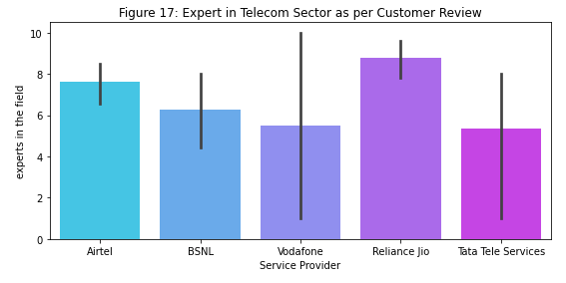

The above graph is showing the overall satisfaction level of selected service providers. Based on the overall satisfaction level of customers Reliance Jio’s trust level is high and they think that Reliance Jio is an expert in the field in this position. Customer who are using Reliance Jio they think that it is the only brand in telecom sector on which they can trust. The internet speed also high and they are charging a fair price. So customer satisfaction is the main part for any business that archives Reliance Jio very much.

**Q17. Charges a fair price for the service it provides. Please answer on a scale from 0 to 10, where 0 means Extremely Dissatisfied and 10 means Extremely Satisfied.**

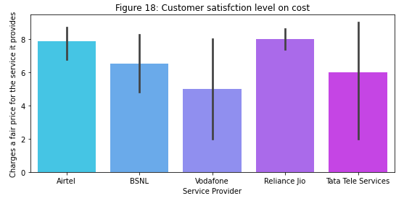

The above graph is showing the customer satisfaction level on the cost that service providers are charging. If the service providers charge a maximum amount than their uses it will put a negative impact on the selected brand. Here the graph represented that those are using Airtel and Reliance Jio are very much satisfied with service charge than other brands. It means that no doubt that Reliance Jio is the most satisfactory brand for the customer but when we are seeing the fair charges then Airtel also here in competition. But customers who are using the other brands like Vodafone, BSNL, and Tata Tele Services are not so much satisfied. So as per the overall satisfaction level of customer Reliance, Jio is the best brand from all aspects.

# Conclusion and Recommendation

## Conclusion

It is found that that sector that are using wireline service they are very much satisfied on that it was varied on the different brand based on their customer service, Internet speed, and landline service. Customers are still believed on leased line and landline. They have changed their service providers but still, they are satisfied with the leased line. It means that no doubt that Reliance Jio is the most satisfactory brand for the customer but when we are seeing the fair charges then Airtel also here in competition. But customers who are using the other brands like Vodafone, BSNL, and Tata Tele Services are not so much satisfied. So as per the overall satisfaction level of customer Reliance, Jio is the best brand from all aspects.

It is found that at the time of re-installation engineer must be down the server to the whole office if the engineer will take a huge time to resolve the issue then it will be a big problem. Engineers must technically very good and they should take minimum time only to resolve the problem. That's the way the field engineer can satisfy the customer. Researchers from the above three graphs have shown that the field engineer Reliance Jio's approach to responsiveness is the best in terms of customer satisfaction. However, Airtel and Reliance Jio are the best in terms of customer satisfaction in terms of both technical problem-solving ability and time. The analysis on customer satisfaction level on service providers now a day Reliance Jio is the best. Customers are satisfied with their internet speed, Billing cost, customer service, etc. From all aspects, Reliance Jio is the best in the telecom sector as per customer review. But Airtel also good in this field as they are charges a fair price for a customer who gets their service.

## Recommendation

Here the researcher has used the Primary data collection model but they can use the secondary data collection model also to analyse the customer satisfaction level. They could collect the previous data from different sites. The sample size could be larger. Due to small funds researcher unable to increase the sample size of the project as they had to pay the data collector per interview (Pantell, 2020). The study only focuses on the positive side of the leased line and landline and how customers are satisfied concerning all brands. The researcher could investigate the negative effect of the leased line connection and landline that make the hinder customer satisfaction.

# References

Alharahsheh, H. and Pius, A., 2020. A review of key paradigms: Positivism VS interpretivism. *Global Academic Journal of Humanities and Social Sciences*, *2*(3), pp.39-43.

Bloomfield, J. and Fisher, M.J., 2019. Quantitative research design. *Journal of the Australasian Rehabilitation Nurses Association*, *22*(2), pp.27-30.

Cambiagno, D.A., Giudicatti, A.J., Arce, A.L., Gagliardi, D., Li, L., Yuan, W., Lundberg, D.S., Weigel, D. and Manavella, P.A., 2021. HASTY modulates miRNA biogenesis by linking pri-miRNA transcription and processing. *Molecular Plant*, *14*(3), pp.426-439.

Etikan, I. and Bala, K., 2017. Sampling and sampling methods. *Biometrics & Biostatistics International Journal*, *5*(6), p.00149.

Geller, J.D., 2020.Marshall McLuhan and the therapeutic importance of the telephone. *Counselling Psychology Quarterly*, pp.1-2.

Grasdijk, J.O., Timgren, O., Kastelic, J., Wright, T., Lamoreaux, S.K., DeMille, D.P., Wenz, K., Aitken, M., Zelevinsky, T., Winick, T. and Kawall, D., 2021.CeNTREX: A new search for time-reversal symmetry violation in the 205Tl nucleus. *Quantum Science and Technology*.

Griebeler, M.L., Pantalone, K.M., Gambino, R., Shewmon, D., Morrow, J., Mendlovic, D., Makin, V., Hamaty, M., Hasan, S., Lansang, M.C. and Zhou, K., 2021. The importance of implementing inpatient virtual coverage in an endocrinology practice: lessons learned thus far from the COVID-19 pandemic. *Clinical Diabetes and Endocrinology*, *7*(1), pp.1-4.

Guterbock, T., Benson, G. and Lavrakas, P., 2018. The changing costs of random digital dial cell phone and landline interviewing. *Survey Practice*, *11*(2), p.3168.

Haunschild, J., Kaufhold, M.A. and Reuter, C., 2020, April. Sticking with Landlines? Citizens’ Use and Perception of Social Media in Emergencies and Expectations Towards Emergency Services in Germany. In *Proceedings of the International Conference on Wirtschaftsinformatik (WI)*.AIS Electronic Library (AISel).

Haunschild, J., Kaufhold, M.A. and Reuter, C., 2020, April. Sticking with Landlines? Citizens’ Use and Perception of Social Media in Emergencies and Expectations Towards Emergency Services in Germany. In *Proceedings of the International Conference on Wirtschaftsinformatik (WI)*.AIS Electronic Library (AISel).

Hong, P.C., Chen, K.J., Chang, Y.C., Cheng, S.M. and Chiang, H.H., 2021. Effectiveness of Theory‐Based Health Information Technology Interventions on Coronary Artery Disease Self‐Management Behavior: A Clinical Randomized Waitlist‐Controlled Trial. *Journal of Nursing Scholarship*.

Kamoun, F. and Outay, F., 2019. IP/MPLS networks with hardened pipes: service concepts, traffic engineering and design considerations. *Journal of Ambient Intelligence and Humanized Computing*, *10*(7), pp.2577-2584.

Kathuria, R., Kedia, M., Varma, G., Bagchi, K. and Sekhani, R., 2018. The anatomy of an internet blackout: measuring the economic impact of internet shutdowns in India.

Kobaiz, A.R. and Ghrare, S.E., 2019. Satphone Systems Overview.

Kunal, S., Saha, A. and Amin, R., 2019. An overview of cloud‐fog computing: Architectures, applications with security challenges. *Security and Privacy*, *2*(4), p.e72.

Pandey, J., 2019. Deductive approach to content analysis.In *Qualitative techniques for workplace data analysis* (pp. 145-169).IGI Global.

Pantell, M.S., 2020. Maintaining social connections in the setting of COVID-19 social distancing: A call to action. *American Journal of Public Health*, *110*(9), pp.1367-1368.

Pantunn, S. and Pattaramalai, S., 2017, March.Security of connecting SIP trunk via SBC on IMS network.In *2017 International Electrical Engineering Congress (iEECON)* (pp. 1-4).IEEE.

Sumter, D., Bakker, C. and Balkenende, R., 2018. The role of product design in creating circular business models: A case study on the lease and refurbishment of baby strollers. *Sustainability*, *10*(7), p.2415.

Sumter, D., Bakker, C. and Balkenende, R., 2018. The role of product design in creating circular business models: A case study on the lease and refurbishment of baby strollers. *Sustainability*, *10*(7), p.2415.

Tongkaw, S. and Tongkaw, A., 2018, November. Multi-Vlan Design OverIPSec VPN for Campus Network. In *2018 IEEE Conference on Wireless Sensors (ICWiSe)* (pp. 66-71).IEEE.

Wang, X., Li, L. and Xie, M., 2019.Optimal preventive maintenance strategy for leased equipment under successive usage-based contracts. *International Journal of Production Research*, *57*(18), pp.5705-5724.

Zelevinsky, T., 2021.The Cold Molecule Nuclear Time-Reversal Experiment (CeNTREX). *Bulletin of the American Physical Society*.

# Appendix

import pandas as pd

import matplotlib.pyplot as plt

importnumpy as np

importseaborn as sns

project_Wireline = pd.read_excel('F:/Python/Neilson/project data.xlsx')

project_Wireline.info()

project_Wireline.describe()

plt.title('Figure 1: Sample size for different service provider')

sns.countplot(x='Service Provider', data = project_Wireline, hue = 'Service Provider')

plt.figure(figsize =(10,4))

plt.title('Figure 2: Customer Satisfaction level on Service Provider')

sns.barplot(x = 'Service Provider', y = 'Rating of Brands', data = project_Wireline, palette = 'hot', hue = 'Service Provider')

plt.figure(figsize =(10,6))

plt.title('Figure 3 : Satisfaction level to connect with Sales Account Manager')

sns.barplot(x = 'Service Provider', y = 'Connection with sales manager', data = project_Wireline, hue = 'Service Provider')

plt.figure(figsize =(10,6))

plt.title('Figure 5 : Satisfaction level to complete negotiation process with Sales Account Manager')

sns.barplot(x = 'Service Provider', y = 'Time taken to complete the negotiation process', data = project_Wireline, palette = 'cool', hue = 'Service Provider')

plt.figure(figsize =(9,6))

plt.title('Figure 5: Customer Satisfaction level on Clarity in installation')

sns.barplot(x = 'Service Provider', y = 'Clarity in installation', data = project_Wireline)

plt.figure(figsize =(9,6))

plt.title('Figutre 6: Customer Satisfaction level on Pro-activeness in installation plan')

sns.barplot(x = 'Service Provider', y = 'Pro-activeness in installation plan', data = project_Wireline, palette = 'cool', hue = 'Service Provider')

plt.figure(figsize =(9,4))

plt.title('Figure 7 : Satisfaction level on Voice Quality')

sns.barplot(x = 'Service Provider', y = 'Voice quality', data = project_Wireline, hue = 'Service Provider')

plt.figure(figsize =(9,4))

plt.title('Figure 8: Satisfaction level on continuous connection without call drops')

sns.barplot(x = 'Service Provider', y = 'Continuous connection without call drops', data = project_Wireline, palette = 'cool', hue = 'Service Provider')

plt.figure(figsize =(9,4))

plt.title('Figure 9: Customer Satisfaction on Internet Speed')

sns.barplot(x = 'Service Provider', y = 'Speed of Internet', data = project_Wireline, hue = 'Service Provider')

plt.figure(figsize =(9,4))

plt.title('Figure 10: Dispute resolution related to Billing')

sns.barplot(x = 'Service Provider', y = 'Dispute in Billing', data = project_Wireline, palette = 'hot', hue = 'Service Provider')

plt.figure(figsize =(9,4))

plt.title('Figure 11: Resolution Update provides by Customer care')

sns.barplot(x = 'Service Provider', y = 'Update provides by Customer care', data = project_Wireline, palette = 'cool', hue = 'Service Provider')

plt.figure(figsize =(9,4))

plt.title('Figure 12: Timely updates on Complain from customer care')

sns.barplot(x = 'Service Provider', y = 'Timely updates on Complaint', data = project_Wireline, hue = 'Service Provider')

plt.figure(figsize =(9,4))

plt.title('Figure 13: Customer Satisfaction on Responsiveness of field Engineer')

sns.barplot(x = 'Service Provider', y = 'Responsiveness of Engineer', data = project_Wireline, palette = 'hot', hue = 'Service Provider')

plt.figure(figsize =(9,4))

plt.title('Figure 14: Customer Satisfaction on Ability of field Engineer')

sns.barplot(x = 'Service Provider', y = 'Ability of engineer', data = project_Wireline, hue = 'Service Provider')

plt.figure(figsize =(9,4))

plt.title('Figure 15: Satisfaction level on time taken by engineer to resolve the technical issue')

sns.barplot(x = 'Service Provider', y = 'time taken by engineer', data = project_Wireline, palette = 'cool', hue = 'Service Provider')

plt.figure(figsize =(9,4))

plt.title('Figure 16 : Trust level on Service provider')

sns.barplot(x = 'Service Provider', y = 'Trusted Brand', data = project_Wireline, palette = 'hot')

plt.figure(figsize =(9,4))

plt.title('Figure 17: Expert in Telecom Sector as per Customer Review')

sns.barplot(x = 'Service Provider', y = 'experts in the field', data = project_Wireline, palette = 'cool')

plt.figure(figsize =(9,4))

plt.title('Figure 18: Customer satisfction level on cost')

sns.barplot(x = 'Service Provider', y = 'Charges a fair price for the service it provides', data = project_Wireline, palette = 'cool')

plt.figure(figsize =(9,4))

plt.title('Figure 19: Provides inovative solutions as per companys productivity')

sns.barplot(x = 'Service Provider', y = 'Provides solutions which enhances my companys productivity', data = project_Wireline, palette = 'hot')